Human remains wash ashore in Florida; 11 on board in Army helicopter crash

|  |
| --- |
|  |
|  |  |  |

[[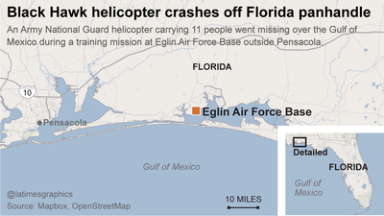](http://touch.latimes.com/#section/607/gallery/p2p-83029368/)](http://touch.latimes.com/" \l "section/607/gallery/p2p-83029368/)

[1 of](http://touch.latimes.com/" \l "section/607/gallery/p2p-83029368/)

ADVERTISEMENT

Related Content

David Zucchino, W.J. Hennigan

March 11, 2015, 9:30 a.m.

Human remains have washed ashore along the Florida coastline after a U.S. military Black Hawk helicopter vanished during a routine training mission Tuesday night with seven Marines and four Army soldiers on board, the military said.

Local law enforcement, the Coast Guard and military members from Eglin Air Force base outside Pensacola, where the helicopter's flight originated, have been searching for debris since the helicopter was reported missing, said Sara Vidoni, an Air Force spokeswoman at the base.

"Fog impeded the search mission this morning, but it is beginning to dissipate," she said, adding that the search efforts has been limited to boats and teams walking the shore because of the fog.

The Marines were from the Marine Corps Forces Special Operations Command, known as MARSOC, said Capt. Barry Morris, a MARSOC spokesman at Camp Lejeune in North Carolina. The soldiers were from a Hammond, La.-based National Guard unit, the Associated Press reported.

The helicopter, an Army National Guard UH-60 Black Hawk, went missing over the Gulf of Mexico about 8:30 p.m. Tuesday, officials said. Search and rescue crews found debris around 2 a.m. Wednesday, said Andy Bourland, spokesman for the Air Force base.

If the Marines are confirmed dead, the Marine Corps will not release their names until 24 hours after their next of kin are notified, Morris said.

"Our focus now is on the search," Morris said. "Our thoughts and prayers are with their families."

Bourland said the helicopter took off from a nearby airport in Destin and joined other military aircraft in the training exercise.

Much of the area was enveloped in fog from Tuesday evening to Wednesday morning, Katie Moore with the [National Weather Service](http://touch.latimes.com/83027772) in Tallahassee told the Associated Press. Much of that time, visibility was at two miles or less, she said.

Vehicles from local law enforcement agencies were gathered Wednesday morning at the crash scene near a remote swath of beach between Pensacola and Destin. The beach is owned by the military and is used for test missions.

*The Associated Press contributed to this report.*

Related Content